Instructions for using SPSS to complete the
One-way ANOVA Training Lab

Open SPSS
Select Type in Data if you are given a choice of what to do when you open SPSS.
You want to end up looking at the Data View with a blank spreadsheet in front of you.
On Page 1 of the One-way ANOVA Training Lab, you will find three columns of raw scores. They are headed by Stop Stank, Fresh Breeze, and Snorp, respectively. You can either copy and paste the data from each column into SPSS, or you can type the scores into SPSS. Either way, you should get in the habit of checking that the numbers in SPSS are correct before continuing with your analyses.

In Data View, copy and paste the 10 scores from the Stop Stank column of raw data into the SPSS column headed by VAR00001 (depending on the version of SPSS, it may just say VAR, in which case, paste into the leftmost column).

Switch to Variable View. You may either click on the Variable View tab in the lower left corner or double-click on the column header (VAR or VAR00001). The latter is recommended because it will bring you directly to the correct row on the Variable View page.

Change VAR00001 to Scores. [This cell will not take any spaces, so use a single word and then elaborate on the details within the Label cell.]
Change Decimals to 0 (if you hate extra 0s where they are not needed).
In the cell under the header of Label, type Effectiveness. This describes the type of scores being entered into the Scores column.
Make sure the cell under Measure says Scale. Recall that Scale represents both Interval and Ratio measures, both of which permit you to perform inferential statistics.

Return to Data View.
In the column headed by VAR00002 (the next one from the left), enter the number 1 next to each of the scores from the Stop Stank group, which we are designating as Group 1.

Beneath the data in the first column (now headed by the label Scores), copy and paste the 10 scores from the Fresh Breeze column of raw data on the first page of the Lab file. Putting the data from one group beneath the data from the other group is called stacking.
In the column headed by VAR00002, enter the number 2 next to each of the scores from the Fresh Breeze group, which we are designating Group 2.

Beneath the data in the first column (now headed by the label Scores), copy and paste the 10 scores from the Snorp column of raw data on the first page of the Lab file.

In the column headed by VAR00002, enter the number 3 next to each of the scores from the Snorp group, which we are designating Group 3.

Switch to Variable View.
Change VAR00002 to Groups.
In the row now named Groups (the second row), click on the cell and then on the ellipses (…) at the right side of the cell, under the column named Values.

In the Value Labels box:
Enter 1 in the Value box and Stop Stank in the Label box, then move the information to the big box selecting ADD.
Enter 2 and Fresh Breeze, then move this information to the big box.
Enter 3 and Snorp, then move this information to the big box.
Select OK.

Return to Data View.
To make the labels (Stop Stank, Fresh Breeze, and Snorp) for the groups visible, select View from the tabs (to the right of File and Edit) and click on the box to the left of Value Labels if it is not already checked.

Select the Analyze tab, then Compare Means and then One-Way ANOVA.
Use the upper arrow to send Effectiveness (Scores) to the Dependent List box.
Use the lower arrow to send Groups into the Factor box.
Click on the PostHoc tab on the upper right. Check the box next to Tukey.
Select Continue.
Click on the Options tab on the upper right. Check the box next to Descriptive.
Select Continue.
Selecting OK will generate the results (output) in a new tab.

In the output file that is created, right click on the box labeled Descriptives and select Copy Special using image/JPEG (delete the other formats first).
Paste the box into your lab worksheet so you can refer to it while completing the worksheet.
Do the same for the boxes labelled ANOVA and Multiple Comparisons (copy special and paste into your worksheet).

Below you will see the results of the PostHoc Comparisons:
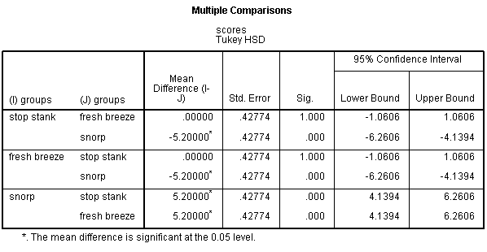
There are two comparisons for each pair of conditions/levels. The first row compares Stop Stank to Fresh Breeze, but the third row compares Fresh Breeze to Stop Stank (so the order of the two is just reversed, but the results have the same absolute value).
This first comparison show sthat there is 0 mean difference between these two air fresheners. The comparison between these two has a Sig. (p) value of 1.00, reflecting the (near) impossibility that these two actually have a different level of effectiveness. I emphasize that it is nearly impossible for these two air fresheners to be different in effectiveness in the real world, yet display exactly the same level of effectiveness in this study. When SPSS returns a Sig. (2-tailed) of 1.000, it should technically be represented by p >.999 [in parallel with the way the APA Manual designates p < .001 as the way to indicate that SPSS has returned a value of .000]. This reflects the inability for us ever to know with complete certainty that the two air fresheners are not truly different in the real world; we can be extremely confident, but not absolutely certain.

The second row compares Stop Stank to Snorp. There is a mean difference between these two conditions of 5.2 points. SPSS reports that this difference is signficant by putting .000 in the Sig. column. This should be reported as p < .001.

The fourth row compares Fresh Breeze with Snorp. There is a mean difference between these two conditions of 5.2 points. SPSS reports that this difference is signficant by putting .000 in the Sig. column. This should be reported as p < .001.

The three rows described above (first, second, and fourth) are sufficient to cover all three possible combinations of these three conditions/levels (because the order of comparison doesn’t matter).

